**Project Outline**

1. Vincent Picot gr9185

Hafsa Hussain gh7070

* We all found multiple open source projects related to the aspect of a library operating system but decided we wanted to implement our own project from scratch.
* Yes, we tried to use the Django framework and decided to use it. Below are screenshots of the tutorial projects that we followed; the full code is on the GitHub repository under the TestDjango folder.

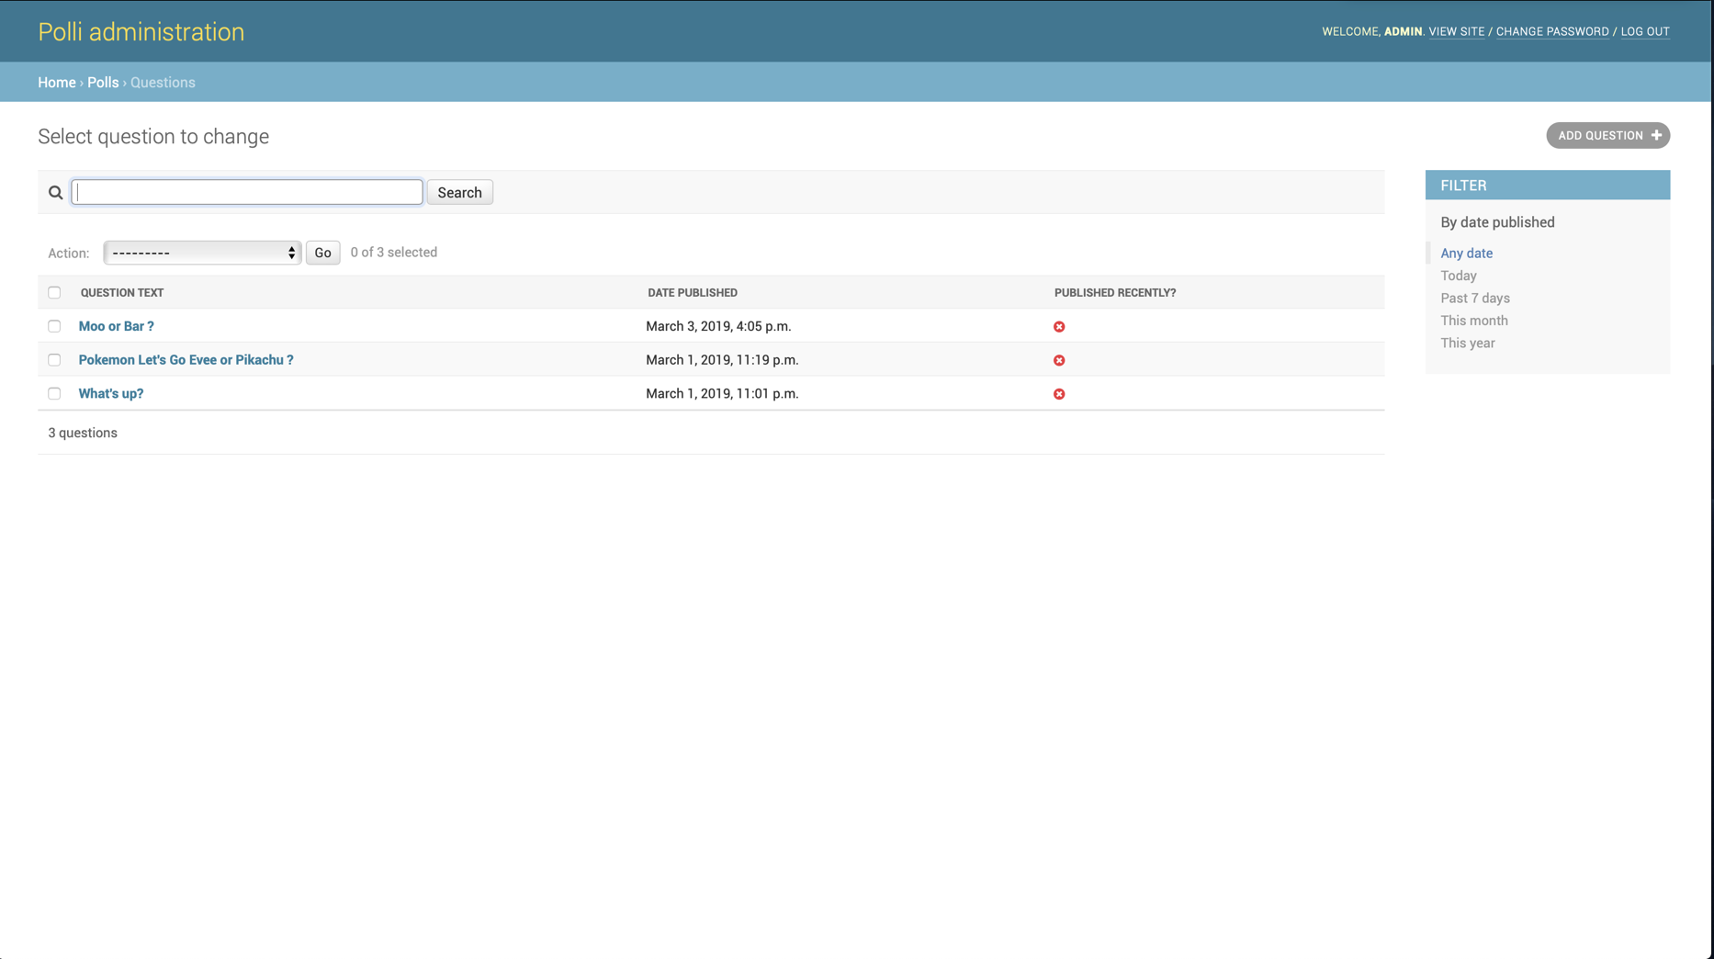Administration page listing the questions.

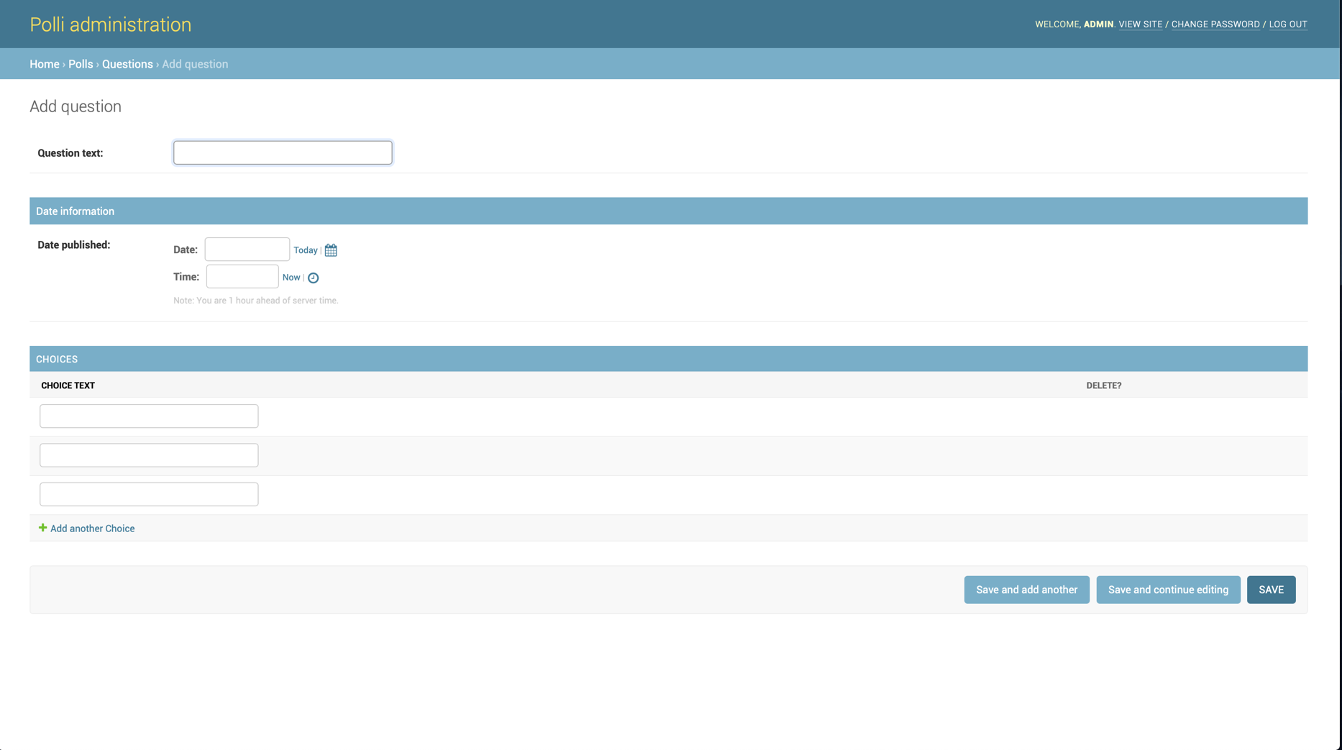Administration page to add a new question and choices

index.html page

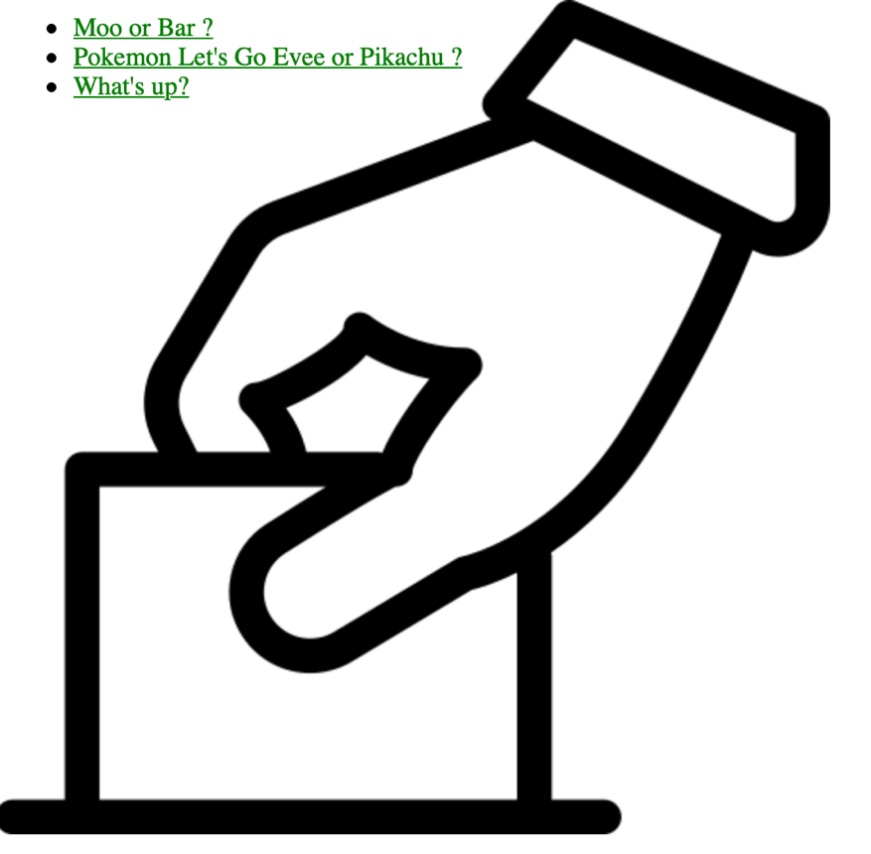

vote.html page

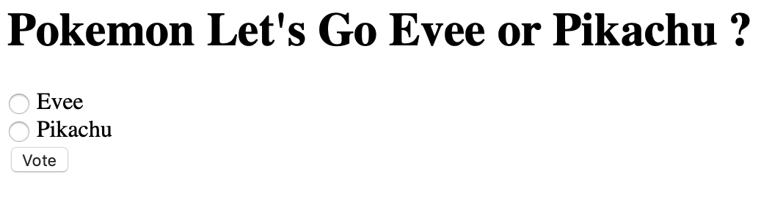

results.html page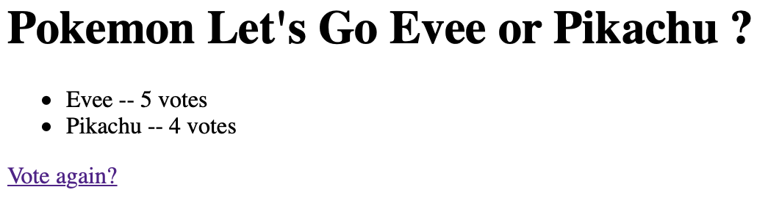

* No, we did not get stuck while trying demos.
* Yes, we have started to implement the front(Hafsa) and back end(Vincent) separately.  
  The process was first to define a database schema as we are doing a CRUD application. For that we made some reflexing on what our application should be able to do. We ended up with this schema:

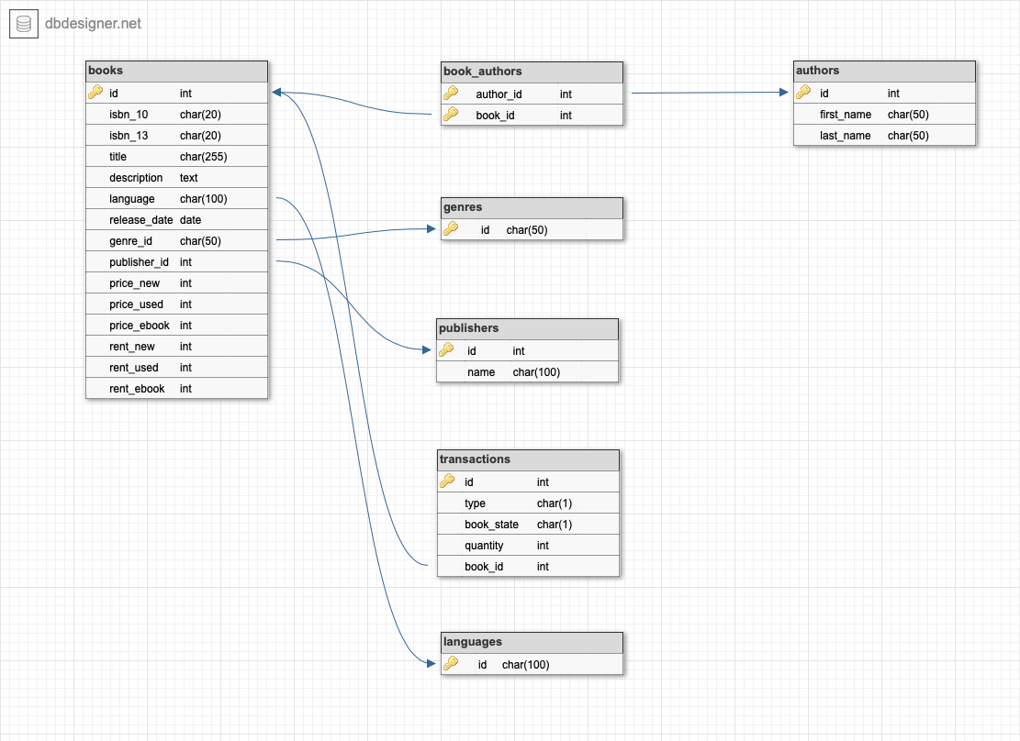

Vincent then created the project structure that Django need and recommend and started to implement this database model into Python Class to use with the Django framework.  
In the meantime, Hafsa started to work on the html and css for the index page of our project and linking this html file with the Python code and Django to create the user interface.

Here are some screenshots of what we did already:

Login page of the administration site

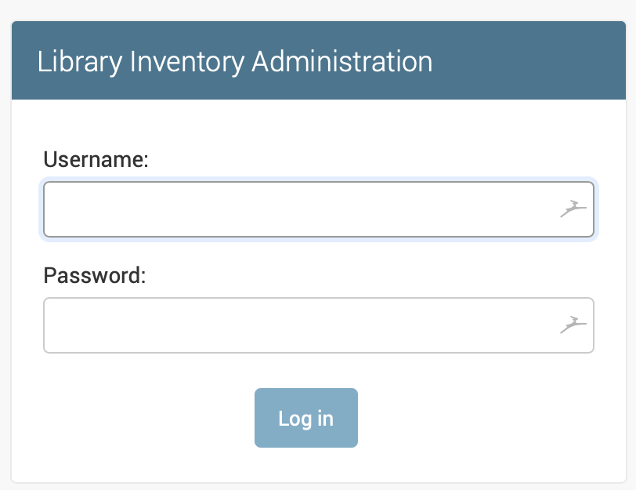

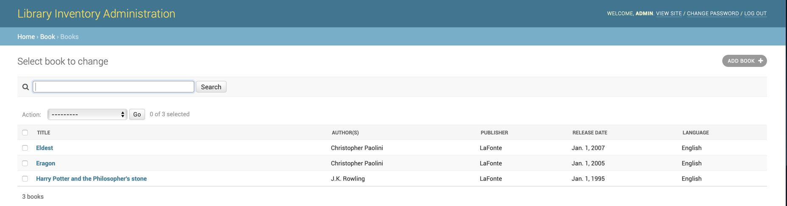List of the book page in the administration site

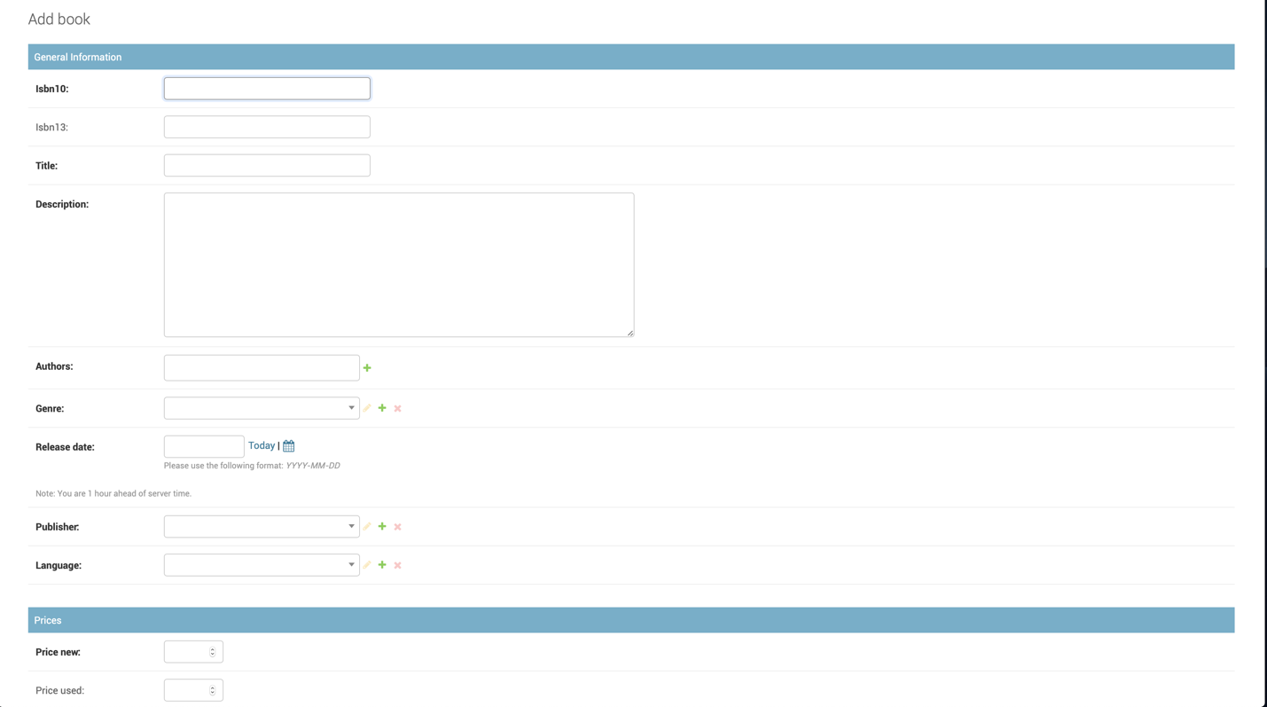Page to add a new book in the administration site

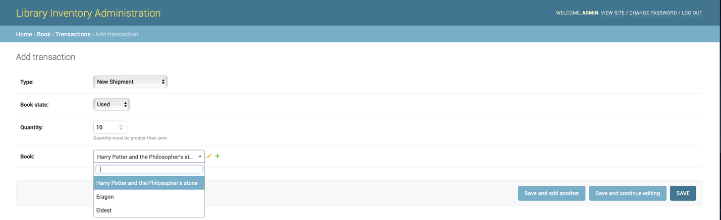Page to add a new book transaction in the administration site

1. Commit screenshot: (Has not been updated for some reason)

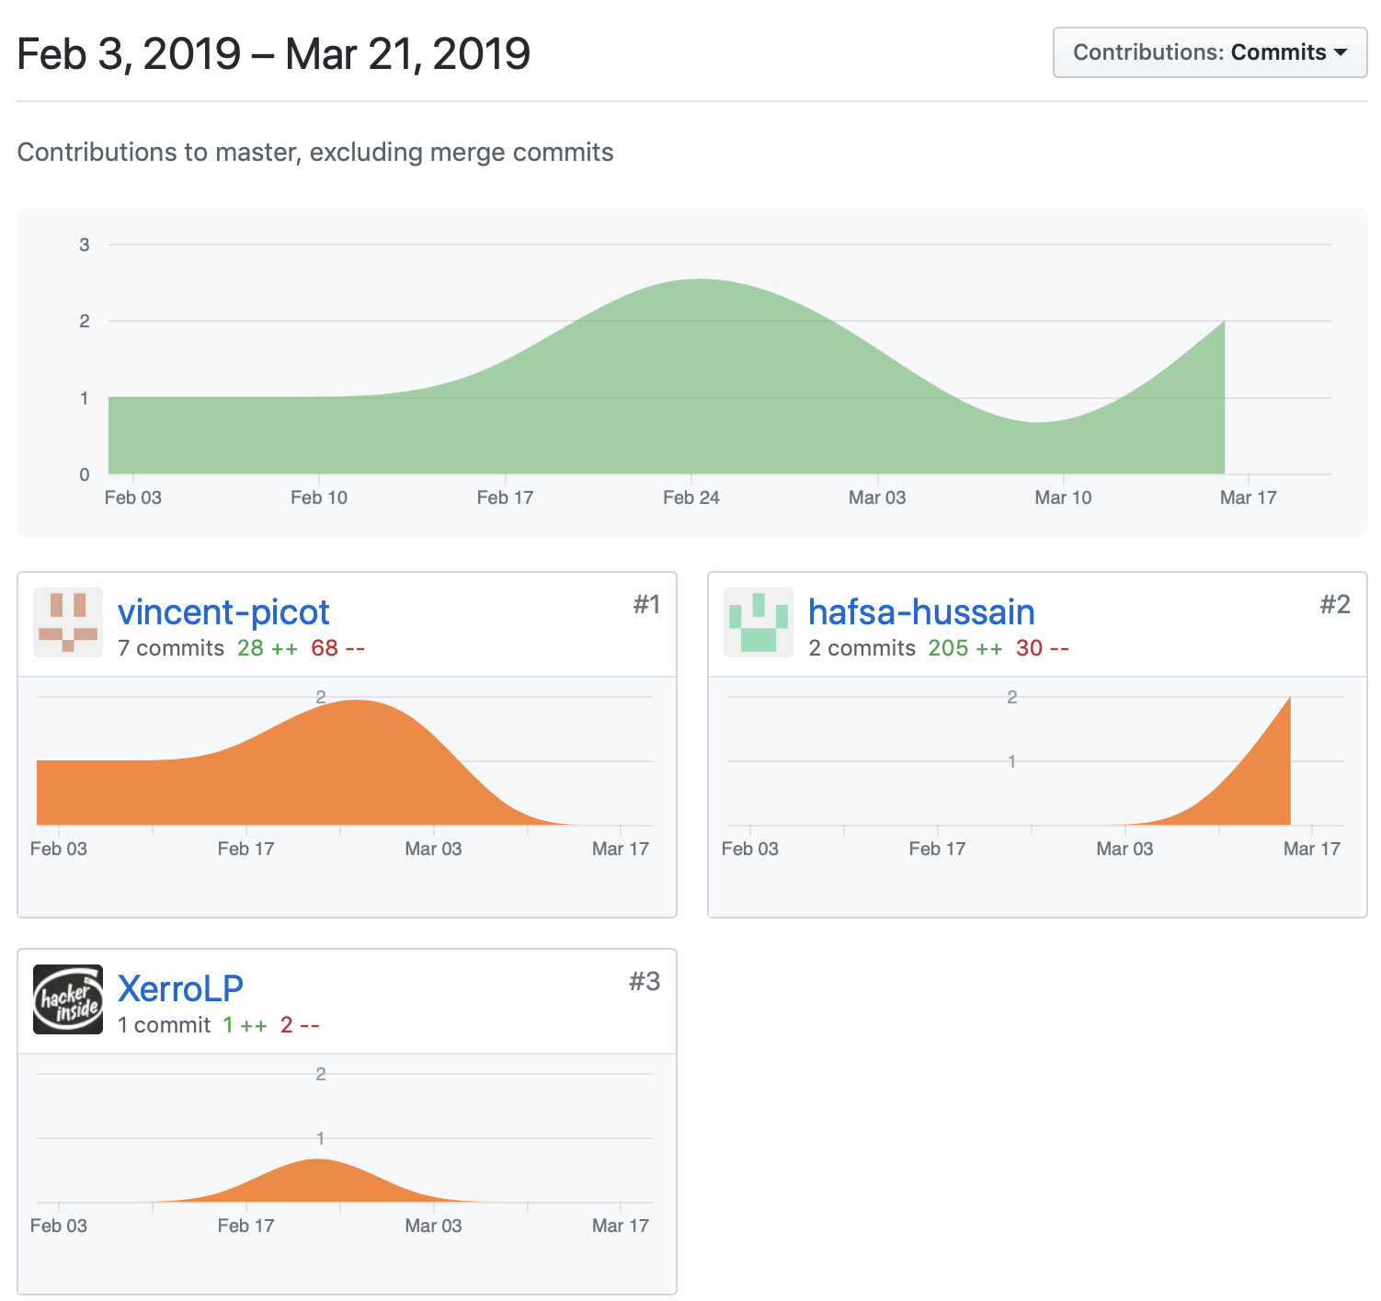

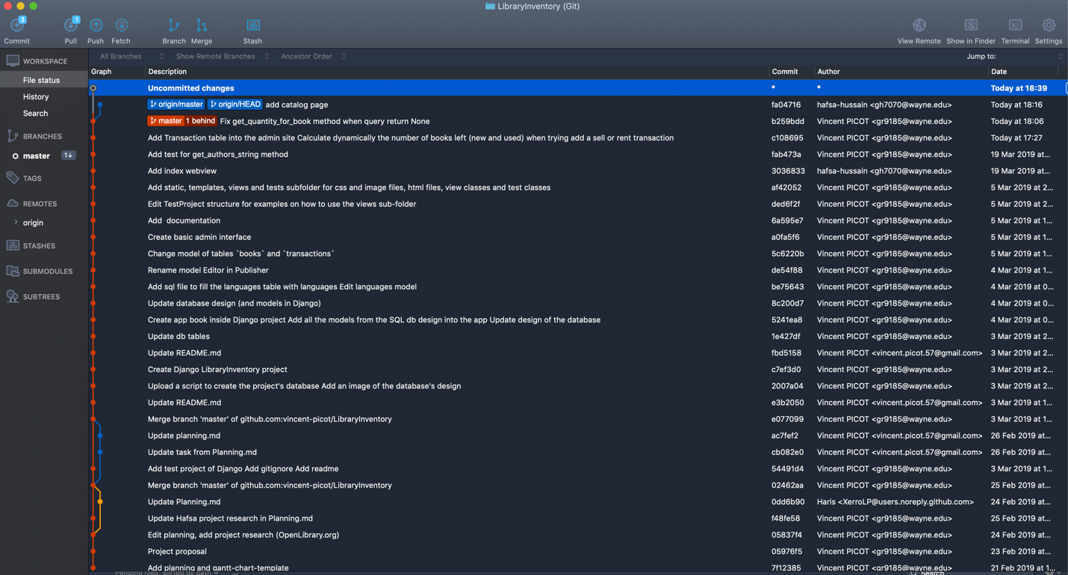

Images of website using html,css, and linking python in a django framework.

A screenshot of a social media post

Description generated with very high confidence

A screenshot of a computer screen

Description generated with very high confidenceA screenshot of a computer screen

Description generated with very high confidenceA screenshot of a computer screen

Description generated with very high confidenceA screenshot of a computer screen

Description generated with very high confidenceA screenshot of a computer screen

Description generated with very high confidence

* Because there are only two of us now, we do not make much use of the Gantt chart or the Kanban board, and rather meet frequently to keep each other updated as well as work together.
* We both work together to brainstorm ideas on how to better our project as well as do the actual coding portion. Originally, the work was split between 3 people but has now changed to 2 which is something we are in the process of adjusting to. Fortunately, we work well together and assist each other when needed.